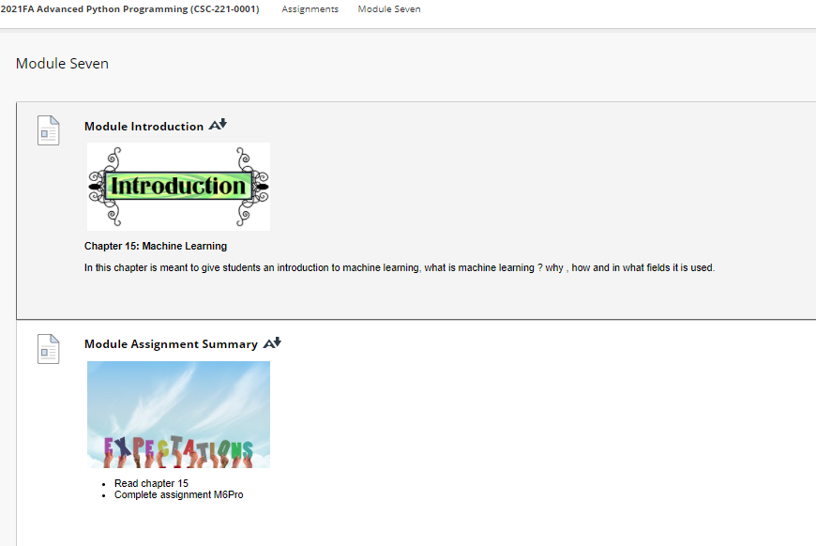

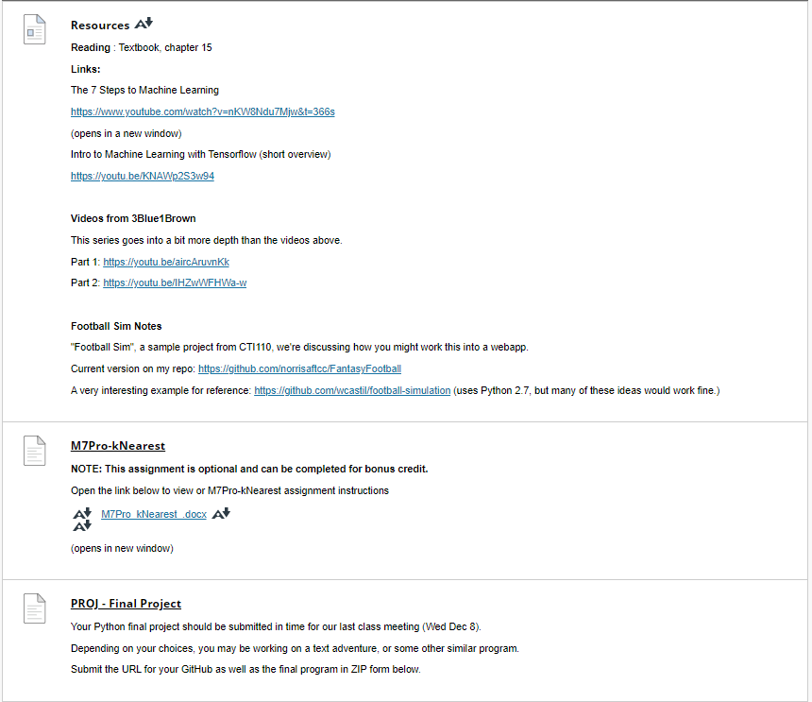

**Resources**

[Resources](https://faytechcc.blackboard.com/webapps/blackboard/content/listContent.jsp?course_id=_35059_1&content_id=_5950151_1)

**Reading** : Textbook, chapter 15

**Links:**

The 7 Steps to Machine Learning

<https://www.youtube.com/watch?v=nKW8Ndu7Mjw&t=366s>

(opens in a new window)

Intro to Machine Learning with Tensorflow (short overview)

<https://youtu.be/KNAWp2S3w94>

**Videos from 3Blue1Brown**

This series goes into a bit more depth than the videos above.

Part 1: <https://youtu.be/aircAruvnKk>

Part 2: <https://youtu.be/IHZwWFHWa-w>

**Football Sim Notes**

"Football Sim", a sample project from CTI110, we're discussing how you might work this into a webapp.

Current version on my repo: <https://github.com/norrisaftcc/FantasyFootball>

A very interesting example for reference: <https://github.com/wcastil/football-simulation> (uses Python 2.7, but many of these ideas would work fine.)